Convert Blocks

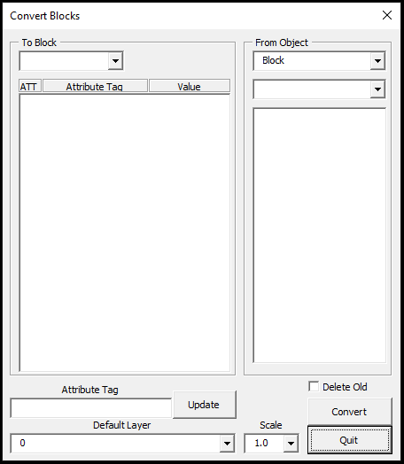

Use this program to convert blocks or points with object data to a block of your choosing. The To Block list and From Object Block list will be generated when you start the program. If the block you want to convert to is missing, stop the program and insert the block into the drawing. If you select From Object Point w/ Object Data, The list will be cleared and filled with all the Object Data tables within the drawing.

For this manual we will convert AddressMTEMCUC points to Customer blocks and put them on the Customers layer.

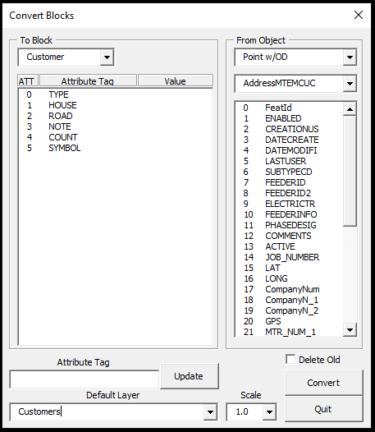

For the Type, we will default to RESIDENCE. To do this, double click on the Type item in the Attribute Tag list. This will change the Attribute Tag label below the list box to read TYPE, and focus will be in the textbox below it.

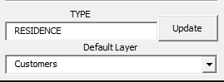

Type RESIDENCE in that textbox and click on Update. 

The addresses for these points are combined in the Object Data. This will require a special format to separate them.

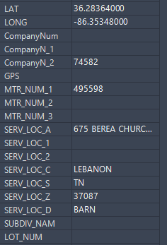

To start, double click on the HOUSE item in the Attribute Tag list. This will change the Attribute Tag label below the list box to read HOUSE, and focus will be in the textbox below it. Now scroll down the listbox on the right until you find the item containing the address. In this case it is 24 SERV_LOC_A.

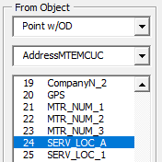

Double click on that item and {24} will appear in the HOUSE textbox.  This will put the full text within the textbox and we only need the first part containing the house number. What separates the number from the rest of the text is a space. The format is:

{number~seperature~position} 

The number in this case is 24 and already entered. Seperature is a space. Position will be first or 1.

The tilde symbol is made by holding shift and the key to the left of the 1 key.

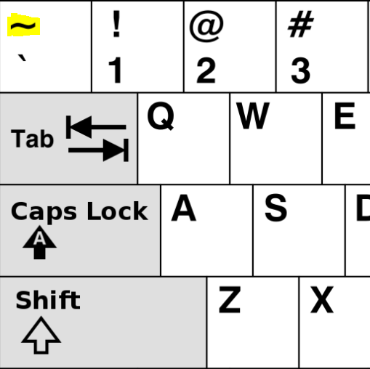

Hit Update to add the format to the Attribute Tag item. 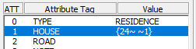

If you add a minus sign before the position in the format, it will keep all of the text minus the position entered. For example we want all but the first position from the address text so we will use {24~ ~-1} 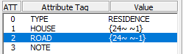

NOTE will be 30 SERV_LOC_D. COUNT will be filled out later by a Designer. SYMBOL will be blank for residences.

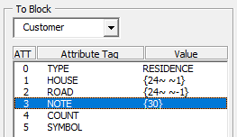

If you want to delete the From Objects after converting, check Delete Old.

Click Convert to start the conversion. Once done, the Convert button will be disabled.

See Convert Customers to change Businesses, Churches, MDUs, Schools, Trailers, and Extensions.